SCHEDULE in USA
Jan.8 @15:40——Jan.09 @05:20 TO NYC
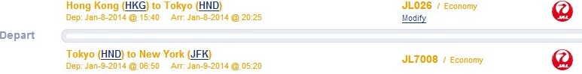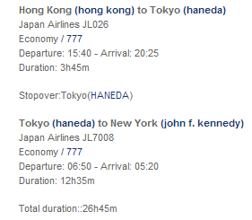

Jan.9@05:20——Jan.14@08:00 NEW YORK
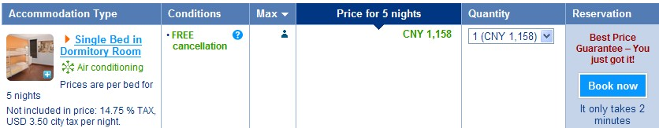
Jan.09 Central Park/ China Town/ The Metropolitan Museum of Art
Jan.10 Statue of Liberty/Ellis Island/ The Fifth Avenue
Jan.11 American Museum of Natural History/Guggenheim Museum/Rockefeller Center
Jan.12 Empire State Building/ United Nations Building/ Broadway/ Time Square
Jan.13 MoMA/ Wall Street/Ground Zero

Jan.14@13:00——Jan.17@06:15 WASHINGTON DC

Jan.14 US Capitol/National Mall/Chinatown/National Gallery of Art
Jan.15 Washington Monument /World War II Memorial /Lincoln Memorial
Jan.16 White House/Library of Congress/ Tidal Basin /Arlington National Cemetery

Jan.17@10:15——Jan.20 @08:15 CHICAGO
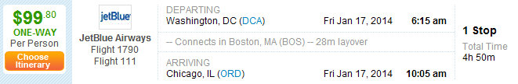
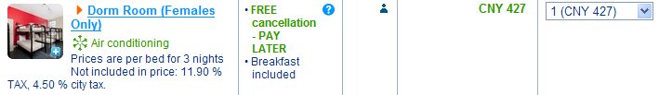
Jan.17 Willis Tower /City Hall / Shedd Aquarium / Monadnock Building/The Field Museum
Jan.18 Millennium Park /Ohio Street Beach /Art Institute of Chicago
Jan.19 Chinatown /Lincoln Park /The Magnificent Mile
Jan.20 @15:15——Jan.23 @08:00 LANSING

Jan.23 @13:00——Jan.23 @17:52 CHICAGO

Jan.23 @17:52——Jan.23 @12:15 New York
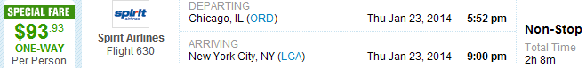


Jan.24@12:15——Jan.26 @14:10 IN FLIGHT TO HK Round trip ticket 7,000 RMB

